Item 7 - Chart D, Comparing Treatment of Recurrent Basic Issues in Various Peace Proposals
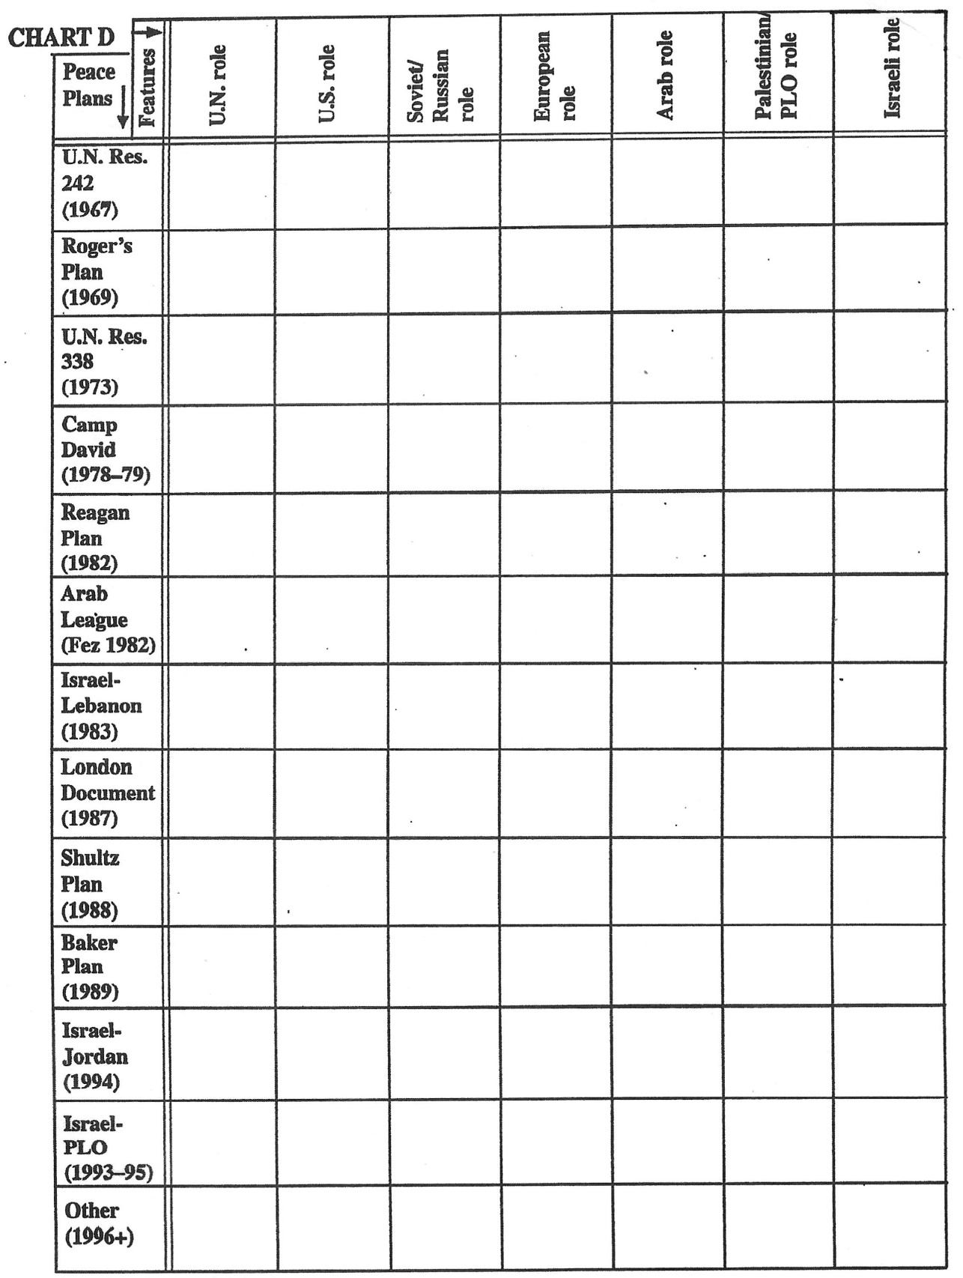
continued
Comparing Treatment of Recurrent Basic Issues in Various Peace Proposals, continued